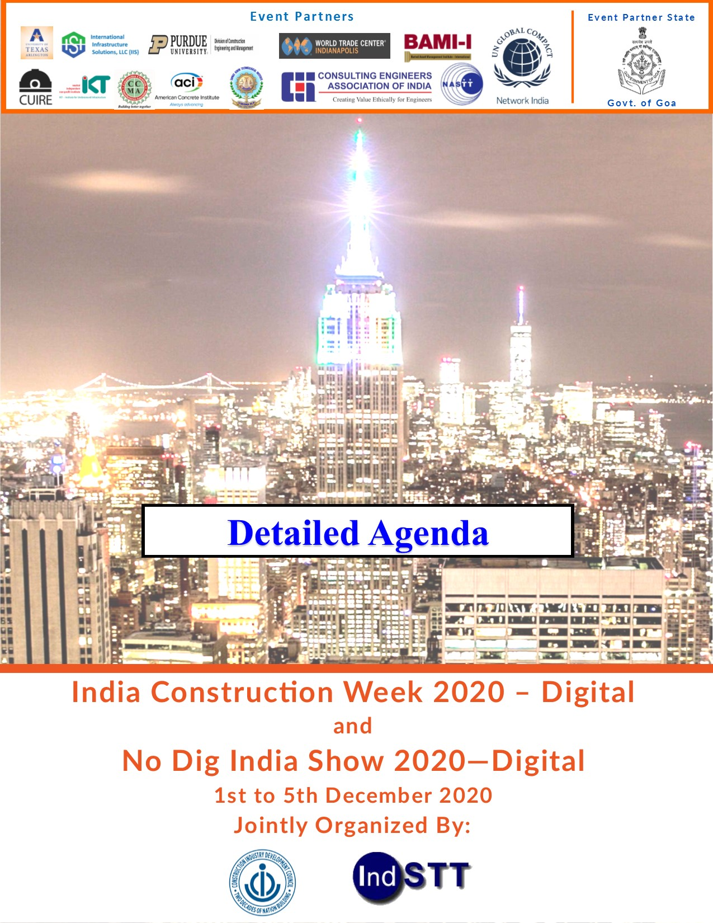
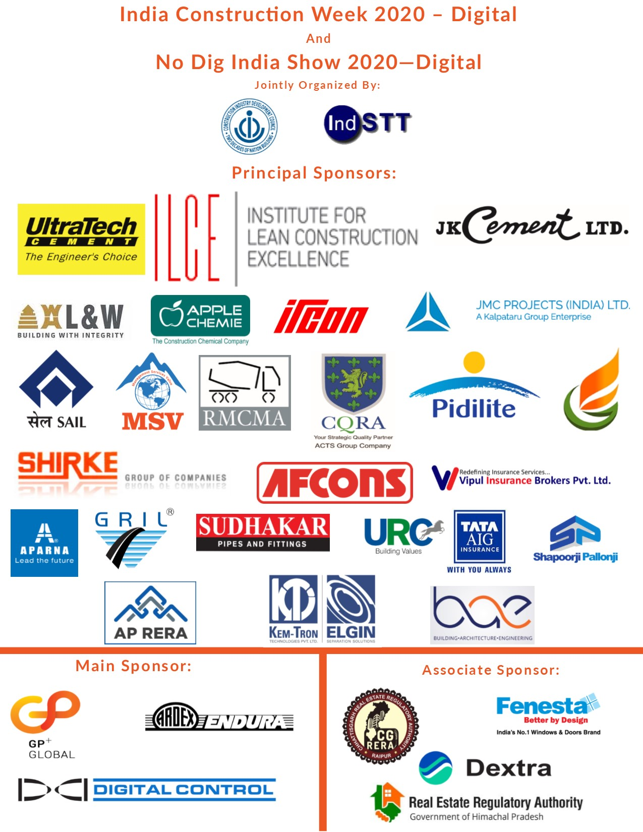

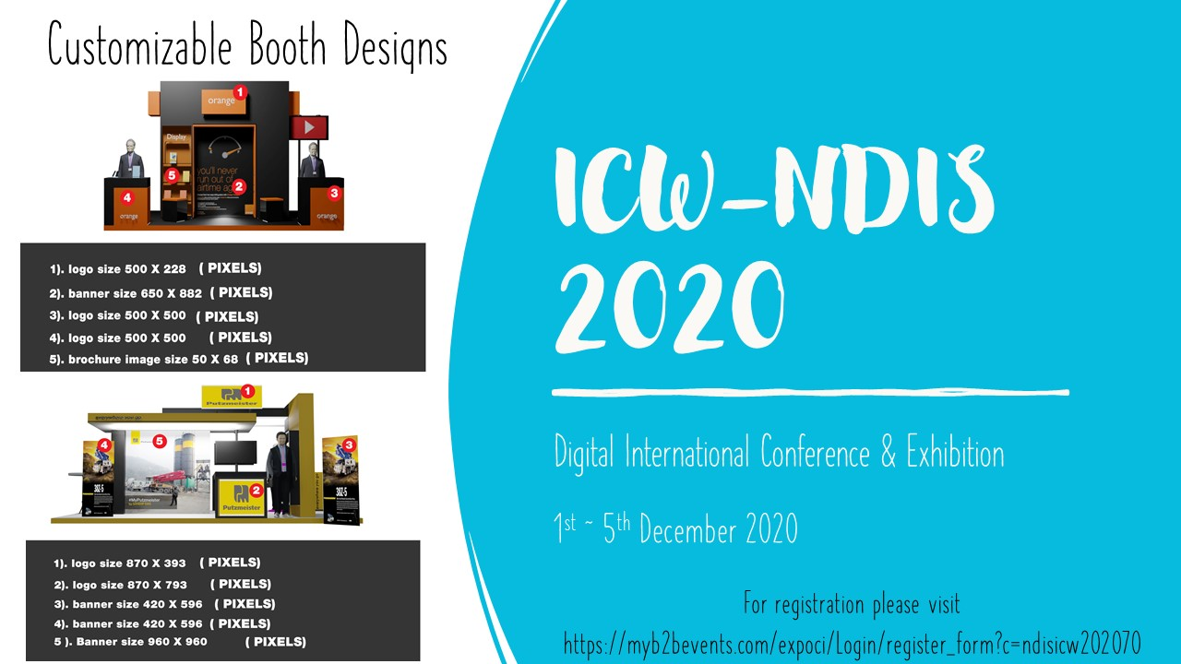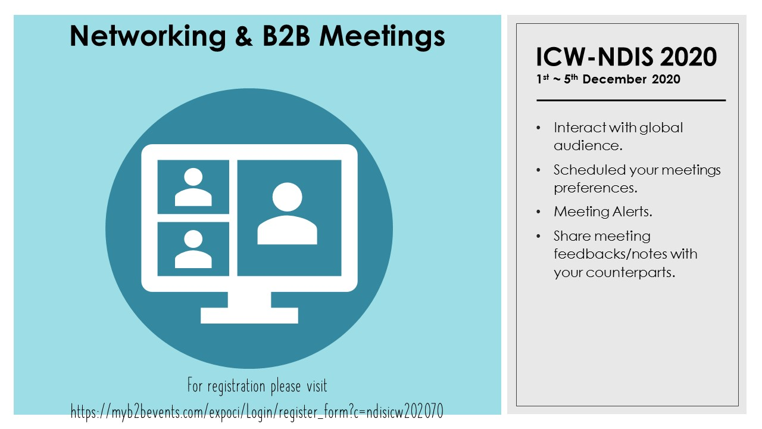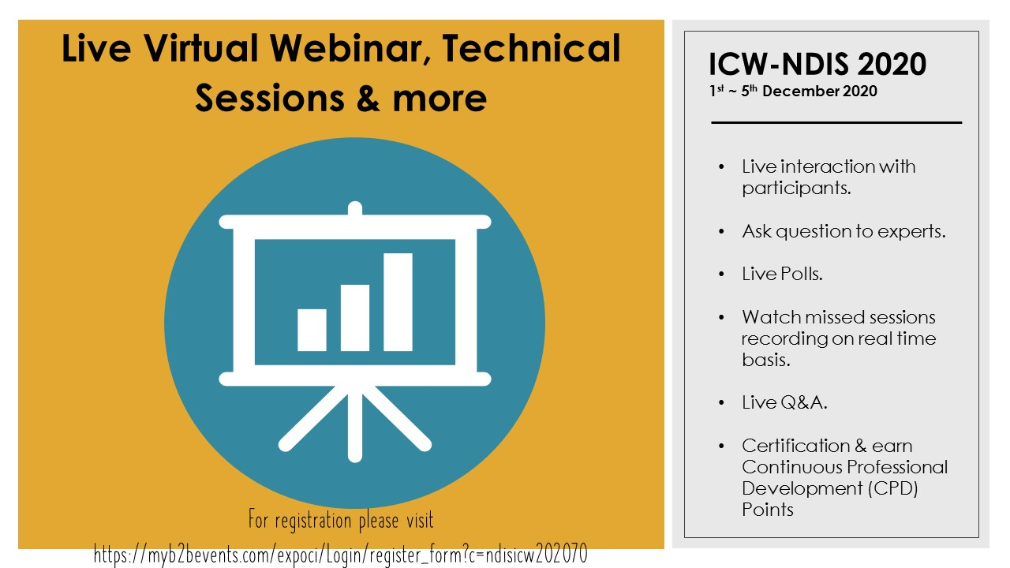

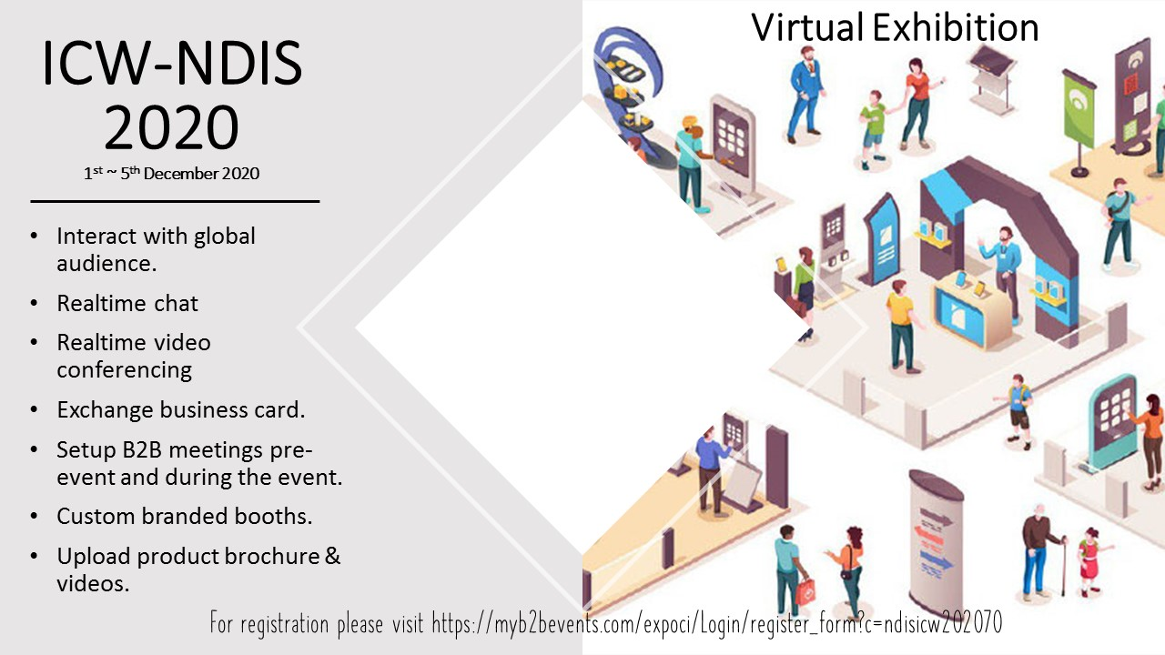

Agenda Index

Sl. No. | Description | Page No.
1 | Day 1 1st December 2020 Program  - Hall 1 Program  - Hall 2 Program  - Hall 3 Program  - Hall 4 Program | 7  8  10  12  13
2 | Day2 2ndDecember 2020 Program  - Hall 1 Program  - Hall 2 Program  - Hall 3 Program  - Hall 4 Program | 14  15  17  18  20
3 | Day 3 3rdDecember 2020 Program  - Hall 1 Program  - Hall 2 Program  - Hall 3 Program  - Hall 4 Program | 21  22  23  25  27
4 | Day 4 4thDecember 2020 Program  - Hall 1 Program  - Hall 2 Program  - Hall 3 Program  - Hall 4 Program | 29  30  32  33  34
5 | Day 5 5thDecember 2020 Program  - Hall 1 Program  - Hall 2 Program  - Hall 3 Program  - Hall 4 Program | 36  37  40  42  44

1stDecember Program

Program Day 1 Hall 1
Program for Day 1
Date 1st December 2020
09.10 -10.30 hrs. |  | Opening ceremony of ICW – NDIS 2020 Digital
09.10 – 09.12 hrs. |  | Compare’s address – Mr. Praveen Tiwari, GM CIDC & Lighting of Digital Lamp
09.12 – 09.14hrs. |  | Welcome Address – Dr. P. S. Rana, Chairman CIDC
09.14 – 09.19hrs. |  | Inaugural Address–Dr. B. D. Mundhra, Patron CIDC
09.19 – 09.21hrs. |  | Inaugural Address – Dr. U. K. Kohli, Chairman Emeritus CIDC
09.21 – 09.25 hrs. |  | Inaugural Address – Mr. Anil Kumar Chaudhary, Chairman SAIL
09.25 – 09.29 hrs. |  | Inaugural Address – Mr. S. K Chaudhary, CMD, IRCON
09.29 – 09.30hrs. |  | Message from Hon’ble CM, Goa
09.30 – 09.31hrs. |  | Message from Hon’ble Governor, Odisha
09.31 – 09.40hrs. |  | Inaugural Address – Dr. Mo. Najafi,  Director CUIRE and Prof. University of Texas at Arlington, USA
09.40 – 10.16 hrs. |  | Trenchless Keynote Address- Dr. Tom Iseley,  Professor of Engineering Practice Beavers Heavy Construction Distinguished Fellow CE & Management, Purdue University, USA
10.16 – 10.20hrs. |  | Chief Guest Address - Dr. Rajeev Kumar, Vice Chairman NITI Aayog
10.20 – 10.21 hrs. |  | Digital Release of Publications
 |  | Message by Mr. Hage Tari, Secretary Industries, Govt. of Arunachal Pradesh
10.21 – 10.30 hrs. |  | Vote of Thanks – Dr. P. R. Swarup, Director General, CIDC
 | 10.30-12.00 hrs. |  | Session 2
 | 10.30 – 10.33hrs |  | Introduction on Disaster Management by Dr. Shuchita Kumar, Director Projects, CIDC
 | 10.33 – 10.43hrs |  | How Construction Sector can help in Disaster Mitigation & contribute for the growth of the Nation by Mr Amandeep Garg,
 | 10.43 – 10.58hrs |  | Owner Driven Construction of Houses (ODCH) - Bringing Back Smiles by Dr. GIRISH CHANDRA JOSHI, Dehradun
 | 10.58 – 11.10hrs |  | CEDAP- NCPDP Building Artisan Education Program by Mr. Rajendra Desai, Ahmadabad
 | 11.10 - 11.41hrs |  | Disaster Resilient Constructions-A, Step Towards Sustainable Habitat by Dr. Chandan Ghosh
 | 11.41 – 11.53hrs |  | Advances in ground Improvement Techniques Biogeotechnics of Granular Soils by Dr. Neelima Satyam
 | 11.53 – 12.04hrs |  | Risk Assessment and Risk Management Approach For Construction Business in Post COVID Situation by Dr. Pramod M. Deshpande
 | 12.04 – 12.20hrs |  | Nondestructive Testing and the Concrete Infrastructure Industry by Mr. Abhijit Ganguli IIT Tirupati
 | 12.20 – 12.30hrs |  | Participant Interactions
 | 12.30-14.00 hrs. |  | Exposition Visits & Break
 | 14.00-16.00 hrs. |  | TECHNICAL SESSION – CONCRETE TECHNOLOGY (FOR ICW-NDIS 2020 DIGITAL)
 | 14.00 – 14.05 hrs. |  | Opening Remarks by Steering Committee Chairman by Dr. S K Manjrekar
 | 14:05 – 14:15 hrs. |  | Reviving construction industry post-Covid in one of the largest Municipal Corporations MCGM Mumbai by Mr. Vinod Chithore & Mr. Sanjay Nirmal
 | 14:15 – 14:41 hrs. |  | World Bank Group - Management of COVID-19 Crisis by Corporate Real Estate by Mr. Jagdish Rele, USA
 | 14:41 – 15:11 hrs. |  | TECHNICAL SESSION – Agro Technology & Infrastructure
 | 14:41 – 14:43 hrs. |  | Introduction by Er. Sunil Mahajan, Addl. Director General CIDC & Convener Steering Committee
 | 14:43 - 15:03 hrs. |  | Overview of Agro-Technology by Chairman of Steering Committee by Padma Shree Prof. Brahma Singh, Chairman, BSHF, Delhi, Former Emeritus Scientist, Member State Planning & Monitoring Board, U.T. of Ladakh
 | 15:03 – 15:11 hrs. |  | Practical Applications of Tech in Agri-business by Shri C. Devarajan, Managing Director, URC Construction P. Ltd.
 | 15:11 – 16:11 hrs. |  | Skilling Initiatives
 | 15:11 – 15:25 hrs. |  | “Skilling needs of Rural Construction workers” by Mr. Prasanna Sriraman, Specialist in Market Systems, Terwilliger Center for Innovation in Shelter
 | 15:25 – 15:39 hrs. |  | ‘Modern Technical Training’ by Er. Sunny Surlakar, Head Technical Services, S S Buildchem Pvt. Ltd.
 | 15:39 – 15:43 hrs. |  | ‘Industry perspective on Skilling initiatives in India’ by Mr. Manish Kumar Singh, CSR Head, Everest Foundation
 | 15:43 – 15:50 hrs. |  | “Ever Changing skilling requirements in India” by Mr. Deepinder Virk, HILTI
 | 15:50 – 16:00 hrs. |  | An Industry Perspective on skilling needs by Mr. Pramod Kumar Mishra, GM (Training and Development), G R Infrastructure Limited.
 | 16:00 -16:15 hrs. |  | Participants Interactions
 | 16:15 -17:00 hrs. |  | Exposition Visits & Break
 | 17.00 – 18 .30 hrs. |  | Session - Real Estate
 | 17.00 – 17.08 hrs. |  | Opening Remarks by Steering Committee Chairman Mr. Velamati Ramnath
 | 17.08 – 17.16 hrs. |  | A Perspective on Real Estate from HP RERA by Dr. Shrikant Baldi, Chairman, Himachal RERA
 | 17.16 – 17.30 hrs. |  | A Perspective on Real Estate from CG CREDAI by Mr. Vivek Dhand, Chairman, Chattisgarh RERA
 | 17.30 – 17.51 hrs. |  | Redevelopment Post Pandemic- Challenges and a way Foreward by Er. Umesh Dhargalkar
 | 17.51 – 18.00 hrs. |  | Industry Perspective on real estate with particular reference to Maharastra State by Mr. Anand J Gupta, CMD, A Y G Realty Pvt. Ltd.
 | 18.00-18.30 hrs. |  | Participants Interactions
End of Day 1

Program Day 1 Hall 2
Program for Day 1
Date 1st December 2020
09.10 -10.30 hrs. | Opening ceremony of ICW – NDIS 2020 Digital
09.10 – 09.12 hrs. | Compares’ address – Mr. Praveen Tiwari, GM CIDC & Lighting of Digital Lamp
09.12 – 09.14hrs. | Welcome Address – Dr. P. S. Rana, Chairman CIDC
09.14 – 09.19hrs. | Inaugural Address–Dr. B. D. Mundhra, Patron CIDC
09.19 – 09.21hrs. | Inaugural Address – Dr. U. K. Kohli, Chairman Emeritus CIDC
09.21 – 09.25 hrs. | Inaugural Address – Mr. Anil Kumar Chaudhary, Chairman SAIL
09.25 – 09.29 hrs. | Inaugural Address – Mr. S. K Chaudhary, CMD, IRCON
09.29 – 09.30hrs. | Message from Hon’ble CM, Goa
09.30 – 09.31hrs. | Message from Hon’ble Governor, Odisha
09.31 – 09.40hrs. | Inaugural Address – Dr. Mo. Najafi,  Director CUIRE and Prof. University of Texas at Arlington, USA
09.40 – 10.16 hrs. | Trenchless Keynote Address- Dr. Tom Iseley,  Professor of Engineering Practice Beavers Heavy Construction Distinguished Fellow CE & Management, Purdue University, USA
10.16 – 10.20hrs. | Chief Guest Address - Dr. Rajeev Kumar, Vice Chairman NITI Aayog
10.20 – 10.21 hrs. | Digital Release of Publications
10.21 – 10.30 hrs. | Vote of Thanks – Dr. P. R. Swarup, Director General, CIDC

1030 - 1135hrs. | Session - Steel
1030 - 1034 hrs. | Chairman’s Message by Mr Anil Kumar Chaudhary, Chairman SAIL & Chairman, Steering Committee on Steel
1034 - 1048 hrs. | Construction & Infrastructure vision of India & Role of Steel by Mr Sushim Banerjee, Former DG, INSDAG
1048 -1102 hrs. | Reasons to stimulate the Steel Construction Industry by Dr S S Mishra, Professor, NIT, Patna
1102 – 1117 hrs. | Tubular Design in High Rise Structures by Mr Gauri Shankar Dubey, Former Executive Director, SAIL
1117 - 1135 hrs. | Steel in Construction by Mr. Prabir Raychaudhury, Former Director (Commercial), RINL
1135 – 1205hrs. | Session - Skilling
1130 – 11.37 hrs. | Opening Remarks by Steering Committee Chairman by Dr. B D Mundhra, Chairman and Managing Director, Simplex Infrastructure Limited
1137 – 1147 hrs. | UP Government Perspective on “Skilling Initiatives Post Pandemic” by Mr. Kunal Silku, Managing Director, UP Skill Development Mission, Government of UP
1147 - 1200 hrs. | Skilling Initiatives In India- A Training Providers Perspective by Dr. Romira Roy, Managing Director, SEED
1205 – 1215hrs. | Participant Interactions
1215-1400 hrs. | Exposition Visits & Break
1400- 1430 hrs. | Session - CEMENT
1400 – 1408 hrs | Chairman’s Message by Mr Sanjay Mathur, Chief Special Initiatives Office, UltraTech Cement Limited
1408 – 1423 hrs | NCCBMs role towards sustainability of Cement and Construction Sector by Dr. B.N. Mohapatra, DG, NCCBM
1423 - 1428 hrs | Role of Cement in Revival of Construction Industry & cementing a Green India by Mr. Shashi Gaggar, Vice President (SIG), Special Initiatives Group, UltraTech Cement Limited
1428 - 1449 hrs | Dry Mix Mortar: Key Influencer in today’s construction by Mr R.K. JHA, G. M [C.T. S], J K Cement Ltd.
1449 -1500 hrs | Challenge and opportunity in RMC a sustainable product by Mr. Ramesh Joshi, President, RMCMA
1500 – 1516 hrs | Green & Sustainable Solutions RMC by Mr. A. K. Jain, Technical Advisor, RMCMA
1516 – 1530 hrs | Role of RMC in Revival of Construction Industry by Mr Atul Desai, Executive Director & CEO, RMC Division, Prism RMC
1530 – 1545 hrs | Concrete Ready Mix the Way Forward for a 25 Trillion Economy by Mr S V Patil, Head RMC & Key Accounts, Ultratech Cement Ltd
1545 – 1600 hrs | Presentation* by Mr. P.N Ojha, HOC CDR, National Council for Cement and Building Materials
1600-16.30 hrs. | Participants Interactions
16.30-17.00 hrs. | Exposition Visits & Break
17.00-18.30 hrs. | Session - PRE-ENGINEERED & PREFABRICATED CONSTRUCTION
1700 - 1706 hrs | Chairman’s Message by Mr. Yogesh Kajale, Vice President (Engineering, Planning & Design), B G Shirke Construction Technology Pvt Ltd
1706 – 1723 hrs | Precast Concrete Construction for Buildings and Way Forward by Prof. N. Raghavan, Professor, Practice, IIT, Madras
1723-1740 hrs | Innovation in Jointing Systems in Precast construction by Prof. C.B.K. Rao, NIT Warangal
1740 - 1800 hrs | Precast Development in India by Mr. C A Prasad, President, PSI & Director, Metey Engineering & Consultancy Pvt Ltd.
18.00-18.15 hrs. | Participants Interactions
End of Day 1

Program Day 1 Hall 3
Program for Day 1
Date 1st December 2020
09.10-10.30 hrs. | Opening ceremony of ICW – NDIS 2020 Digital
09.10 – 09.12 hrs. | Compares’ address – Mr. Praveen Tiwari, GM CIDC & Lighting of Digital Lamp
09.12 – 09.14hrs. | Welcome Address – Dr. P. S. Rana, Chairman CIDC
09.14 – 09.19hrs. | Inaugural Address–Dr. B. D. Mundhra, Patron CIDC
09.19 – 09.21hrs. | Inaugural Address – Dr. U. K. Kohli, Chairman Emeritus CIDC
09.21 – 09.25 hrs. | Inaugural Address – Mr. Anil Kumar Chaudhary, Chairman SAIL
09.25 – 09.29 hrs. | Inaugural Address – Mr. S. K Chaudhary, CMD, IRCON
09.29 – 09.30hrs. | Message from Hon’ble CM, Goa
09.30 – 09.31hrs. | Message from Hon’ble Governor, Odisha
09.31 – 09.40hrs. | Inaugural Address – Dr. Mo. Najafi,  Director CUIRE and Prof. University of Texas at Arlington, USA
09.40 – 10.16 hrs. | Trenchless Keynote Address- Dr. Tom Iseley,  Professor of Engineering Practice Beavers Heavy Construction Distinguished Fellow CE & Management, Purdue University, USA
10.16 – 10.20hrs. | Chief Guest Address - Dr. Rajeev Kumar, Vice Chairman NITI Aayog
10.20 – 10.21 hrs. | Digital Release of Publications
10.21 – 10.30 hrs. | Vote of Thanks – Dr. P. R. Swarup, Director General, CIDC

10.30-12.00hrs. | Session 2 New Dig India Show 2020 Addresses
10.30-11.00 hrs. | Introduction to new publications released during No Dig India Show 2020 by Dr. Niranjan Swarup, Director General, INDSTT
11.00-11.15 hrs. | Address from IKT by Dr. Bert Bosseler
11.15- 11.30 hrs. | Address from NASTT by Mr. Craig Vandaelle, Chairman NASTT, USA
11.30- 11.50hrs. | Professional Development of Utility Specialist by Ir Dr. King Wong, FHKIUS, FIIUS, RPUS, Executive President, IIUS, Hong Kong
11.50-12.00hrs. | Participant Interactions
12.00-14.00 hrs. | Exposition Visits & Break
14.00-16.00 hrs. | Session 3 Investigations for Trenchless Projects
14.00-14.30 hrs. | Geo Physical Techniques for Trenchless Technology Installation by Dr. Sanjay Rana, Chairman Parsan Overseas Pvt. Ltd
14.30 – 15.00 hrs. | Sub Surface Utility Engineering by Dr. Sanjay Rana, Chairman Parsan Overseas Pvt. Ltd.
15.00 – 15.30 hrs. | Geo Physical Method for Pipeline Rehabilitation Projects by Dr. Sanjay Rana, Chairman Parsan Overseas Pvt. Ltd.
15.30-16.00 hrs. | Participants Interactions
16.00-17.00 hrs. | Exposition Visits & Break
17.00 – 18 .30 hrs. | Session 4 IKT Workshop
17.00 – 17.24 hrs. | Sewer Operation in the Pandemic by Dr. Ian Naismith
17.24- 17.47 hrs. | Flowable Backfill In Sewer Construction by Dr. Ian Naismith
17.47-18.10 hrs. | Rehabilitation of Sewer Manholes by Dr. Ian Naismith
18.10-18.30 hrs. | Participants Interactions
End of Day 1
Program Day 1 Hall 4
Program for Day 1
Date 1st December 2020
09.10-10.30 hrs. | Opening ceremony of ICW – NDIS 2020 Digital
09.10 – 09.12 hrs. | Compares’ address – Mr. Praveen Tiwari, GM CIDC & Lighting of Digital Lamp
09.12 – 09.14hrs. | Welcome Address – Dr. P. S. Rana, Chairman CIDC
09.14 – 09.19hrs. | Inaugural Address–Dr. B. D. Mundhra, Patron CIDC
09.19 – 09.21hrs. | Inaugural Address – Dr. U. K. Kohli, Chairman Emeritus CIDC
09.21 – 09.25 hrs. | Inaugural Address – Mr. Anil Kumar Chaudhary, Chairman SAIL
09.25 – 09.29 hrs. | Inaugural Address – Mr. S. K Chaudhary, CMD, IRCON
09.29 – 09.30hrs. | Message from Hon’ble CM, Goa
09.30 – 09.31hrs. | Message from Hon’ble Governor, Odisha
09.31 – 09.40hrs. | Inaugural Address – Dr. Mo. Najafi,  Director CUIRE and Prof. University of Texas at Arlington, USA
09.40 – 10.16 hrs. | Trenchless Keynote Address- Dr. Tom Iseley,  Professor of Engineering Practice Beavers Heavy Construction Distinguished Fellow CE & Management, Purdue University, USA
10.16 – 10.20hrs. | Chief Guest Address - Dr. Rajeev Kumar, Vice Chairman NITI Aayog
10.20 – 10.21 hrs. | Digital Release of Publications
10.21 – 10.30 hrs. | Vote of Thanks – Dr. P. R. Swarup, Director General, CIDC

10:30 – 12:00 hrs. | Day – 1 Session- 2, Academia
10:30 - 10:43 hrs. | Welcome Address by Prof P.K Garg, IIT, Roorkee
10:43–11:34 hrs. | Technical Presentation on Laser and Drone Survey by Prof P.K Garg
11:34–12:03 hrs. | Flood Hazard Management for smart city development by using computer simulation, Remote sensing & GIS by Prof. T I Eldho, IIT, Bombay
 | Participant Interactions
 | Exposition Visits & Break
14.00-17.00hrs | Day – 1 Session- 3, Educational Stream
14.00-17.00hrs | Systematic Approach to waterproofing for durable construction
End of Day 1

2nd December Program

Program Day 2 Hall 1
Date 2nd December 2020
Day & Time | Session 1
09:30 – 11:05 hrs. | Session 1A - PRE-ENGINEERED & PREFABRICATED CONSTRUCTION
09:30 – 09:45 hrs. | Indigenization in setting up precast Industry in India by Mr. Satyanarayana, Managing Director, Inventaa Industries Ltd., Hyderabad
09:45 – 09:55 hrs. | Inner Engineering in construction for Sustainability & Productivity by Mr. Raj Pillai, MD, Starworth Infrastructure Pvt Ltd
09:55 – 10:10 hrs. | 11 Storey Residential Apartment Building Constructed using Precast Construction Technology at Dundigal Hyderabad by Mr C.A. Prasad, President, PSI
10:10 – 10:25 hrs. | Do it right the second time by Mr. T P Singh Director, Construction Research Technologies
10:25 – 10:50 hrs. | Precast Work and Jointing of Panels by Mr. Vivek Naik, CEO & Managing Director, Apple Chemie India Pvt. Ltd
10:50 – 11:05 hrs. | “Some aspects of Site Administration in Precast Building Projects by Mr Anand Gosavi, Partner, A.A.PMC & ENGINEERING LLP
11:05 – 12:10 hrs. | Session 1B - STEEL
11:05 – 11:25 hrs. | Waste to Wealth from Steel Slag by Mr Gauri Shankar Dubey, Former Executive Director, SAIL
11:25 – 11:50 hrs. | Strategy to enhance Steel Consumption by Mr. T.K. Sahu, Former, ED (Commercial), SAIL
11:50 -12:10 hrs. | Lifecycle cycle costing in steel construction by Mr P K Sen, DG, INSDAG
12.10-14.00 hrs. | Exposition Visit & Break
14:00 – 16:10 hrs. | Session 2 - ENERGY (POWER, OIL & GAS)
14:00: - 14:10: hrs. | Introduction Shri. Ashutosh Bhardwaj Director (Corporate Affairs), CIDC  & Convener Steering Committee on Energy, ICW 2020
14:10 -14:20 hrs. | Chairman’s address by Shri Balraj Joshi (Former CMD), NHPC Ltd
14:20– 14:40 hrs. | Impact of resource wastage on Indian Economy including Indian Construction Industry by Shri Sunil Gupta (Additional Vice President) BSES Yammna Power Ltd
14:40 – 15:10 hrs. | Understanding investigations for tunnels in Himalayas by Dr. Gopal Dhawan (Founder & Chairman) by Dr. Dhawan Academy of Geologist
15:10 - 15:25 hrs. | Construction and Sustainable Development Course by Dr. Bhaskar Chatterjee (Director General & CEO) Indian Institute of Corporate Affairs
15:25 - 15:50 hrs. | Sustainable Developments Goals by Shri. Aseem Kumar (Head, Asia Pacific Resource Centre) Global Compact Network, India
1550 - 16.10 hrs. | Exposition Visit & Break
16.10-18.10 hrs. | Session 3 - SUSTAINABILITY
16:10 - 17:05 hrs. | Construction Compliance of SDGs by Prof JL Narayan Former Adviser Ministry of Statistics & Programme Implementation, Consultant ADB, UN Adviser, Advisor Commonwealth and Management Consultant
17:50 - 17:25 hrs. | The Sustainable Development Goals 2030 by Ms Anupma Kohli
17:25-18:10 hrs. | Participant Interactions
End of Day 2

Program Day 2 Hall 2
Date 2nd December 2020
Timing | Session
09:30 – 13:00 hrs. | Session 1 - ILCE
09:30 - 09:40 hrs. | About ILCE by Mr. Anup Mathew, Chairman-ILCE BOD, Business Head- Godrej Construction & C. Devarajan, Director-ILCE, Managing Director URC Constructions
09:40 - 10:10 hrs. | Introduction to Lean Construction by Prof. N. Raghavan, Director- ILCE, Prof. of Practice IIT Madras
10:10 - 10:30 hrs. | Lean Construction & Automation by Dr. Koshy Varghese, Director-ILCE, Department of Civil Engg, IIT Madras
10:30 - 11:40 hrs. | Exposition of Lean Construction Tools & Case Studies by various Practitioners
11: 40- 11:50 hrs. | Intermission (Exposition Visit & Break)
11:50 - 12:45 hrs. | Construction Experts on Benefits from Lean and Guidance to projects by Mr Subodh Dixit (Shapoorji Pallonji-E&C), Mr Giridhar Rajagopalan (Afcons), Mr C. Devarajan (URC), Mr R. Shankar Narayanan (L&T Construction) & Prof. N. Raghavan
12:45 - 12:50 hrs. | Future possibilities for Lean in Indian Construction Industry by Dr Koshy Varghese and Prof. N. Raghavan-IIT Madras
12:50 - 13:00 hrs. | ILCE action plan for the future Mr. Kaezad Karanjawala, Secretary General-ILCE
13:00 – 14:00 hrs. | Exposition Visit & Break
16:00 – 18:05 hrs. | Session 2 - ILCE
16:00 - 16:05 hrs. | Welcome address & About ILCE by Anup Mathew, Chairman-ILCE BOD &  Business Head - Godrej Construction
16:05 - 16:35 hrs. | A Brief Introduction to Lean Construction by Prof. N. Raghavan, Director- ILCE, Prof. of Practice IIT Madras
16:35 - 17:55 hrs. | Panel Discussion with Experts form Construction Industry on Lean Practices and Benefits form Lean - Moderated by Dr Ashwin Mahalingam, IIT -Madras Panel: ILCE Directors Mr Anup Mathew (Godrej Construction), Prof. N. Raghavan (IIT Madras), Mr Giridhar Rajagopalan (Afcons), Mr C.Devarajan (URC), Mr R. Shankar Narayanan (L&T Construction), Dr Koshy Varghese (IIT-M)
17:55 - 18:00 hrs. | Future possibilities for Lean in Indian Construction industry by Dr Koshy Varghese & Prof. N. Raghavan- IIT Madras
18:00 - 18:05 hrs. | Future Plans for ILCE, Vote of thanks by Mr. Kaezad Karanjawala- Secretary General, ILCE

Program Day 2 Hall 3
Date 2nd December 2020
09.30 to 12.10 hrs. | Session 1 - CONCRETE TECHNOLOGY
09:30 to 10:00 hrs. | “The transformation of the concrete industry in the face of the challenge of COVID 19 in Mexico” by Dr. Arturo Gaytan Covarrubias
10:00 to 10:30 hrs. | Social appropriation and application of corrosion and concrete knowledge in the face of pandemics and natural disasters by Dr. Pedro Castro Borges
10:30 to 10:45 hrs. | “Post Covid-19 Concrete Technology, New Norms and Best Practice in Singapore. By Dr. Lu Jin Ping
10:45 to 11:05 hrs. | “Accessible and Sustainable Construction in Tropical Areas after COVID-19: Standard INTE C170: 2020, RESET” by Eng. Thyssen Wong,
11:05 to 11:35 hrs. | Reinforced Concrete Durability in Iberoamerican Environments DURACON Project: during and post Pandemic Regime by Dr. Oladis Troconis de Rincón
11:35 to 11:50 hrs. | Finding our feet on challenging construction times by Ms. Alma Reyes Aurac
11:50 to 12:10 hrs. | What awaits construction industry in circular economy era by Dr. Ömer ÇİMEN
12.10-14.00 hrs. | Exposition Visits & Break
14:00 to 16:05 hrs. | Session 2 - CONCRETE TECHNOLOGY
14:00 to 14:30 hrs. | Engineered Cementitious Composites (ECC) for Masonry and Concrete Structures necessity to post covid construction scenario by Dr. Shamsher Singh
14:30 to 14:45 hrs. | Food Industry Concrete Surface Protection Requirements of COVID19 by Dr. Guillermo Loayza
14:45 to 15:10 hrs. | Process of construction elevated viaducts and bridges precasted as response to speed up the process due to the pandemic by Dr. Martin Polimeni
15:10 to 15:40 hrs. | "Challenges in the design and use of self-healing concretes" by Dr. Fernanda Pacheco
15:40 to 16:05 hrs. | Embedding innovation and resilience for sustaining growth in unfavourable economic periods: A Northern Ireland Model by Dr. Sreejith Nanukuttan
 | Exposition Visits & Break
16:05 – 18:00 hrs. | Session 3 - CONCRETE TECHNOLOGY
16:05 to 16:20 hrs. | Roles of High-Performance Concrete in Post Covid World” by Dr. Zack Lim
16:20 to 16:40 hrs. | “Measures adopted by the construction industry of El Salvador in the wake of COVID19” by Dr. Wilfredo Guerrero
16:40 to 17:00 hrs. | “The effects of COVID-19 on the construction industry of Turkey and the possible remedies for the past pandemic period” by Prof. Dr. Nilufer Ozyurt Zihnioglu
17:00 to 17:20 hrs. | “Advances in concrete technology: Thinking Post Covid-19” by Dr. Omar J. Silva Rico
17:20 to 17:30 hrs. | “Qualifying alternatives for greening the construction industry – A case study on the use of recycled concrete aggregate” by Dr. Mayuri Wijayasundara
17:30 to 18:00 hrs. | Unlocking the Unlocked" by Mr. Aniruddha Nakhawa

Program Day 2 Hall 4
Date 2nd December 2020
09:30 – 12:00 hrs. | Session 1 – Education
09:30 – 09:43 hrs. | LiDAR Technology for Mapping for Modern Constructions by Dr. Bharat Lohani, IIT-Kanpur
09:43 – 10:13 hrs. | Management of Earthquake Risks, Challenges & Issues (Life, Property, Environment) by Prof Rahul Ralegaonkar, VNIT-Nagpur
10:13 – 11:06 hrs. | Bio cementation - An Eco-Friendly Technique for structural amelioration of cementitious materials by Dr. Madhuwanti Latkar, VNIT-Nagpur
11:06 – 12:00 hrs. | Educational Streams
12:00 - 02:00 hrs. | Exposition Visits & Break
02:00 – 03:53 hrs. | Session 2 - Education
02:00 – 02:40 hrs. | NEP 2020: A WAY FORWARD TO RESURGENT AND ATMA NIRBHAR BHARAT - Dr Anil Kumar, SPA, SPIU, Uttar Pradesh
02:40 – 03:02 hrs. | USE OF SMALL UNMANNED AERIAL VEHICLES (sUAVs) AND MACHINE LEARNING (ML) TECHNIQUES IN CIVIL ENGINEERING - Dr Bushra Zaman, Nodal Officer (Academic), SPIU, Bihar
03:02 – 03:15 hrs. | IMPARTING EDUCATION AT THE TIME OF PANDEMIC - Prof V B Vanvari,Head, CE, SVKM's SBMP, Mumbai
03:15 – 03:35 hrs. | Post Covid World – The Face of Online Internship - Er. Umesh Dhargalkar, Dhargalkar Technoesis (I) Pvt. Ltd, Mumbai
03:35 – 03:53 hrs. | Online Engineering Education Model During Covid-19 - Dr. J B Dafedar, N. K. Orchid College of Engineering & Technology, Solapur
03:53 - 05:00 | Exposition Visits & Break
05:00 – 06:00 hrs. | Session 3 - Education
05:00 – 06:00 hrs. | Educational Streams
End of Day 2

3rdDecember Program

Hall 1 Program Day 3
Date 3rd December 2020

Time | Sessions
9:30 – 11:30 hrs. | Session 1 – Construction Equipment & Machinery
09:30 to 09:35 hrs. | Introduction by Mr. S.N. Murthy Director Finance, CIDC
09:35 - 09:40 hrs. | Introduction by the committee chair – Construction Equipment & Manufacturing by Mr. Ranjeet More-CMD Universal Construction Machinery and Equipment Limited.
09:40 - 09:50 hrs. | Introduction to good practices in Construction by Mr. Praveen Tiwari – General Manager, CIDC
09:50 - 10:10 hrs. | Mr. Rakesh Reddy, Director, Aparna Construction and Estates Pvt. Ltd.
10:10 - 10:25 hrs. | Mr. Manish Kumar Singh, Head CSR - Everest Industries Ltd
10:25 - 10:40 hrs. | Mr. Pushkar Malik- Managing Director, MSV International INC
10:40 – 11:30 hrs. | Participant Interactions
11:30 – 12:40 hrs. | Session 2- Engineering Consultancy
11:30 – 11:50 hrs. | Challenges and opportunities for the engineering consulting industry in the post covid era by Shri Vidyashankar Hoskere
11:50 – 12:20 hrs. | Project Management, Getting India Ready to Build World-Class Tourism Destinations by Shri Vikram Chopra
12:20-12:40 hrs | Revising International view on Regulatory Mechanism of Professions Engineers by Shri Sanna Ratnavel
12:40 – 14:00 hrs. | Participant Interactions
14:00 – 16:00 hrs. | Exposition Visits & Break
14:00 – 14:30 hrs. | Rejigging Approaches for Post-Covid Construction Scenarios by Dr. Ramprakash N
14:30 – 15:00 hrs. | Water and Climate Positive Infrastructures for Post- Covid19 by Dr. S. Mohan
15:00 - 15:30 hrs. | Role of Consulting Engineers in RERA & Expectation more for Engineers from RERA by Er. K. Sundarapandian
15:30 – 16:00 hrs. | Digitization and mechanisation of Constructionby Shri S. Subramanian Tata
16:00 – 17:00 hrs. | Exposition Visit & Break
17:00 – 18:30 hrs. | Session 4 – Engineers Consultants
1700 - 17:30 hrs. | The role of consulting engineers in social mass housing - Singapore model/ policy matters by Shri Rajavel Inbarajan
18:00 - 18:30 hrs | Participant Interactions

Hall 2 Program Day 3
Date 3rd December 2020
Day & Time | Sessions
9:30 – 12:00 hrs. | Air Conditioning Heating & Refrigeration
9:30 – 9:45 hrs. | Equipment Certification drives Energy Efficiency and Lowers Global Warmingby Shri Vikram Murthy - AHRI & Chairman Steering Committee
9:45 – 9:55 hrs. | ISHRAE's Advocacy - the path to enabling better Building Systems by Shri Richie Mittal, President, ISHRAE
9:55 – 10:00 hrs. | Technical Committees drive better Practiceby Shri Vishal Kapur - ISHRAE
10:00 – 10:20 hrs. | Medium and Small Enterprises Manufacturing for India - the catalysts for rapid upscaling by Shri Ajit Panicker, President, RATA
10:20 – 10:25 hrs. | Manufacturing to meet the Challenges of the Pandemic and beyond by Shri Jitendra Bhambure - RAMA
10:25 – 10:45 hrs. | The India Cold Chain drives progress across India by Shri L N Krishna, RAMA
10:45 – 12:00 hrs. | Participants Interactions
12:00 – 14:00 hrs. | Exposition Visits & Break
14:00 – 16:10 hrs. | Session 2 - CIAC-CIDC Dispute Resolution
14:00 – 14:15 hrs. | Significant changes in the ‘Arbitration and Conciliation Act 1996 by Er. Gursharan Jit Singh Rosha
14:15 – 14:30 hrs. | Synopsis - Proposed Article on ‘Departmental Arbitration Clauses by Adv. Sougat Sinha, Advocate, Artha, Advocates & Legal Advisor
14:30 – 14:40 hrs. | Adjudication, a fang-less process of Resolving Construction Disputesby Adv. Amod K. Dalela, Managing Patner Dalela & Dala
14:40 – 15:00 hrs. | Virtual Arbitration and remote advocacy by Adv. Ratan K Singh
15:00 – 15:10 hrs. | Time is a essence of contract and its effect on Arbitrationby Er. Chandrasekhar Gurudas Prabhudessai, RCC Consultancy and valuation of Immovable Properties (Land and Building)
15:10 – 15:30 hrs. | Practice Techniques for Successful Adr by Mr. Naresh Kumar
15:30 – 15:40 hrs. | Systematic Approach for Dispute Resolution in Joint Venture Contract for Construction Industryby Er. Vaibhav Gupta, Life Member - ICI, IRC & IBC
15:40 - 15:50 hrs. | Proper Drafting of Contract Agreement to Avoid Disputes – A case Studyby Er. Krishna Kant, Former UN C.E.
15:50 - 16:10 hrs. | Type & Nature of Claims likely to come upby Dr. Sanjay Kumar Goyal, Director
16:10 – 17:00 hrs. | Exposition Visits & Break
17:00 – 19:10 hrs. | Session 3 – CIAC-CIDC Dispute Resolution
17:00 – 17:10 hrs. | Petty Contractors need Institutional Arbitration and need CIAC by Er. Vijay Kumar Gupta, Retd. (Chief Engineer MES)
17:10 – 17:25 hrs. | Use of Online Dispute Resolution and Challengesby Adv. Meenakshi Mukherjee, Practicing Advocate West Bengal State
17:20 – 17:35 hrs. | Methodology to be adopted for Disposal of Disputeby Prof (Er.) O.P Gupta, VSM, Acting Registrar, CIAC
17:35 – 18:50 hrs. | Issues Between Architect and client – Disputes & Remediesby Arch. D K Santoshi, Architect Consultant Former Sr. Architect, Consultant Arbitrator DDA & Arbitrator
18:50 – 19:10 hrs. | Implementation of block chain in construction by CA Surinder Kumar Kalra, Practicing Chartered Accountant

End of Day 3

Hall 3 Program Day 3
Date 3rd December 2020
Day & Time | Sessions
09:30 – 12:30 hrs. | Session 1- ‘Construction Chemicals approach to solve post COVID construction challenges’’.
09:30 - 09:35 hrs | Introductory remarks by Mr. Sanjay Bahadur
09:35 - 09:45 hrs | Spray Plasters for rapid construction by Mr Rakesh Shah
09:45 - 09:50 hrs | Smart Concrete Solutions by Mr Nilotpol Kar
09:50 - 10:05 hrs | ‘’Healthy coatings for healthy environments- freedom from bacteria and virus’’ by Dr Subash Cipy
10:05 - 10:35 hrs | ‘’Advancement in Tile Adhesives’by Dr Arjunan
10:35 - 11:25 hrs | ’Stopping Leakages by Injections’’by Mr Samir Surlekar
11:25 - 12:05 hrs | ‘’EIFS – An Energy Efficient Architectural Façade Solution“ by Mr. Prasad Satavse and Mr. Juan Tejederas Perez -Spain
12:05 - 12:30 hrs | ‘’Introduction to Construction Chemicals- Industry Overview’’ by Mr. Samir Surlaker
12:30 -14:00 hrs. | Exposition Visits & Break
14:00 – 16:15 hrs. | Session 2 – EMERGING TECHNOLOGIES IN CONSTRUCTION & INFRASTRUCTURE
14:00 – 14:10 hrs. | Introduction by Shri. Ashutosh Bhardwaj Director (Corporate Affairs), CIDC & Convener Steering Committee on Energy, ICW 2020
14:10 – 14:15 hrs. | Chairman’s addressby Dr P R Swarup (Director General), CIDC
14:15 – 14:20 hrs. | Message by Er Vivek Naik (CEO & Managing Director), Apple Chemie India Pvt. Ltd.
14:20 – 14:35 hrs. | Construction in Post COVID Scenario by Er Vivek Naik (CEO & Managing Director), Apple Chemie India Pvt. Ltd.
14:35 – 14:55 hrs. | Cordless Technology by Shri Sharan Grover (Product Manager), Hilti India
14:55 -15:10 hrs. | Dust Free Construction by Shri Harsh Vardhan Verma (Product Manager), Hilti India
14:10 – 15:30 hrs. | Disrupting Construction with 3 D Printingby Shri. Adithya Jain (Conference Coordinator) Tvasta Manufacturing Solutions Pvt Ltd
15:30 – 15:55 hrs. | Emerging Technologies in Constriction – A CSIR-SERC Perspective by Prof. Santosh Kapuria (Director) CSIR-Structural Engineering Research Centre
15:55: - 16: 15 hrs. | Construct Next by Intelligent Building Systems by Shri Sunil Prabhaker (Chief Executive Officer) Building Architecture Engineering
16:15 – 17:00 hrs. | Exposition Visits & Break
17:00 – 18:55 hrs. | Session 3 - EMERGING TECHNOLOGIES IN CONSTRUCTION & INFRASTRUCTURE
17: 00 - 17:25 hrs. | Catapulting Construction Industry with Powerful Artificial intelligence Applications by Shri Himanshu Ujjawal Singh (Director), Aglo 8 & by - Shri. Nandan Mishra, (Founder), Aglo 8
17:25 - 17:50 hrs. | Construction technologies that foster economical construction i.e., more output with lesser workforce involving advanced material & equipmentby Shri Sunny Surlaker (Head Technical Services) Assess Build Chem Private Ltd.
17:50 - 18:05 hrs. | Integrated Approach to Construction Projectby Prof. N. Raghavan, FNAE, FICE(UK), FIE(I), Professor of Practice, BTCM Division Department of Civil Engineering, Indian Institute of Technology Madras,
18:05 - 18:20 hrs. | Innovative Materials for Sustainable Constructionby Er Vivek Naik (CEO & Managing Director), Apple Chemie India Pvt. Ltd.
18:20 - 18:40 hrs. | Post COVID Construction –Is 3D Printing of concrete and Action by Shri. Manu Santhanam, Professor and Head Department of Civil Engineering, IIT Madras
18:40 – 18:55 hrs. | BIM for Construction Companies & relevance to Sustainability and post COVID scenario by Ms. Anupma Kohli. Head, Anupama & Associates, Architects & Mr. Ashit Goyal, Architects and Consultants, Anupama Associates – BIM Serv.
End of Day 3

Hall 4 Program Day 3
Date 3rd December 2020
Day & Time | Sessions
09:30 – 11:00 hrs. | Session 1 – Steel
09:30 - 09:45 hrs. | Emerging trends in steel construction by Dr. Susmita Dasgupta Policy Economist, JPC, Ministry of Steel
09:45 – 10:00 hrs. | Strategies to enhance steel consumption by Mr. Sanjeev Duggal, Director and Chief Operating Officer Bruce Clay India Private Limited
10:00 -11:00 hrs. | Rural & Urban Housing for all Role of Architects / Designers for Steel Intensive Buildings Sustainability of Steel by Green Architect by Dr. Hemanta Doloi, Associate Professor, University of Melbourne
11.00 –13:25 hrs. | Pre-Engineering & Prefabricated Construction
11:00 – 11:25 hrs | Advances in evaluation of building construction technologiesby Dr. Ajay Chourasia, CSIR-Central Building Research Institute, Roorkee
11:25 – 11:45 hrs | Earthquake Safety of Precast Buildings by Dr Pradeep Kumar Ramancharla, IIIT-Hyderabad
11:45 – 11:55 hrs. | Innovative materials for sustainable constructionby Mr. Vivek Naik, CEO & Managing Director, Apple Chemie India Pvt. Ltd
11:55 – 12:10 hrs. | Pharmaceutical Industrial R & T Building Using Precast Construction Technology by Mr. C. A. Prasad Director, Metey Engineering & Consultancy Pvt. Ltd
12:10 – 12:30 hrs. | Prefabricated construction by Mr. Ajit Bhate, MD, Precast India Infrastructure Pvt. ltd. Pune
12:30 – 12:55 hrs. | Design of Precast in highrise Commercial Building by Mr. Sanjeev Sharma, Director, Mecor Structural Solutions
12:55 – 13:10 hrs. | Precast Concrete Construction policy Reforms needed and Contract Condition by Mr. Surya Prakash, M.D Satyavani Consultants Pvt.Ltd.
13:10- 13:25 hrs. | Release of CBRI Documentary on Emerging Construction Prefab Technologies for Housing by Mr. Y P Kajale. Chairman Steering Committee Pre Engineered and Pre-fabricated Construction and Message by Dr. P R Swarup , Director General, CIDC
13:25-14:00 hrs. | Exposition Visits & Break
14:00-16:00 hrs. | Session-2 Engineering Consultancy
14:00 to 14:15 hrs. | Address as chairman by Shri Sanna Ratnavel
15:20 to 15:50 hrs. | Digitization and mechanisation of Constructionby Shri S. Subramanian Tata
15:50 to 15:55 hrs. | Effect of Covid-19 on Consultancy Sector of Construction Industry by Shri. V K. Gupta
15:55 -16:00 hrs. | Participant Interaction
16:00-17:00 hrs. | Exposition Visits & Break
End of Day 3

4thDecember Program

Hall1 Program -Day 4
Date 4th December 2020

Time | Session
09:30 – 12:00 hrs. | Session-1 Disaster Management
9:30-9:45 hrs. | Owner Driven Construction of Houses (ODCH) - Bringing Back Smiles by -  Dr.Girish Chandra Joshi, Dehradun
9:45-10:00 hrs. | RETROFIT YOUR MASONRY BUILDING WHY & HOW by - Mr. Rajendra Desai, Ahmadabad
10:00-10:30 hrs. | Basic Video - Disaster Management by - Er. Vijay Gupta
10:30-10:50 hrs. | Construction Beyond Municipal Boundaries of Himachal Pradesh - An Issue of Concern by - Dr Hemant Kumar Vinayak
10:50-11:00 hrs. | Construction Management by - Dr. S.K. Dhawan, Former Chief Engineer CPWD Delhi High Court Commissioner Delhi High Court Arbitrator
11:00 – 12:00 hrs. | Participants Interactions Q & A
12:00 – 14:00 hrs. | Exposition Visits & Break
14:00 – 16:45 hrs. | Session-2 Agro Technology & Infrastructure
14:00 – 14:15 hrs. | Infrastructure Construction for Accelerated Growth in Agriculture  by Dr. R. K. Singh, Ph.D. Project Coordinator  All India Coordinated Research Project on Plastic Engineering in Agriculture Structures and Environment Control  ICAR-Central Institute of Post-Harvest Engineering & Technology
14:15 – 14:30 hrs | ENTREPRENEURSHIP IN AGRICULTURE by Shri Laxman Kumar Palata Singh, Former Deputy Director of Agriculture & State Project Coordinator, APICOL, Bhubaneswar, Odisha, India
14:30 – 14:45 hrs | MSV International INC presentation on Irrigation, Agro Technology and initiatives to Combat COVID. By Mr Pushkar Malik, MD, MSV International INC
14:55 – 16:55 hrs | Steering Committee 1st Meeting
14:55 – 16:55 hrs | Participants -  1. Padma Shree Prof. Brahma Singh, Chairman, BSHF, Delhi, Former Emeritus Scientist, Member State Planning & Monitoring Board, U.T. of Ladakh  2. Shri C Devarajan, Managing Director, URC Construction (P) Ltd.  3. Shri Asaithambi Manickam, Managing Director, L & W Construction Private Limited  4. Prof. Indra Mani Mishra, President, Indian Society of Agricultural Engineers (ISAE)  5. Dr VPS Arora, Professor Emeritus, Sharda University, Noida &  Former Dean, College of Agri- Business GBPUAT  6. Dr. Basant Ram, former Vice Chancellor, Rajendra Agriculture University Pusa, Samastipur, Bihar and N.D. University of Agriculture & Technology, U. P.  7. Dr. Mahendra Singh, former Director Extension & Professor Agronomy, G. B. Pant University, Pantnagar  8. Mr. Rajib Bishoyi, Director, PAL Nutrients Private Limited  Odisha  9. Dr. Ashish Kumar Singh, Principal Scientist (Food Technology), Dairy Technology Division, National Dairy Research Institute, Karnal  10. Dr. D N Yadav, Principal Scientist (Food Technology), ICAR-Central Institute of Post-Harvest Engineering & Technology, Ludhiana  11. Dr M S Alam, Professor (Agricultural Structure & Process Engineering), ICAR-Central Institute of Post-Harvest Engineering & Technology, Ludhiana, Punjab  12. Dr P K Sahoo, Principal Scientist, Agril Engg, IARI, New Delhi  13. Dr. P. R. Swarup, Director General CIDC
16:55 – 18:00 hrs. | Exposition Visit

End of Day 4

Hall 2 Program Day 4
Date 4th December 2020
TIME | TOPIC
09:30 – 12:00 hrs. | Session 1 - CONCRETE TECHNOLOGY
9:30-09:45 hrs | Turkey Construction Materials Industry During COVID Pandemic - Foresight for Post COVID" -  Dr. Bekir Y. Pekmezci
09:45-10:00 hrs. | How Brazilian Construction Industry Is Planning Recovery Post Covid 19. - Dr. Arthur Medeiros
10:00 – 10.35 hrs | Sustainable Construction Materials and Methods for Infrastructure and Housing Solutions: An Indian perspective -  Dr. K.V.L. Subramaniam
10:35 – 10.45 hrs | “Ill effects of Pandemic in UK Construction Industry”- Dr. Satish Desai
10:45 – 11.05 hrs | Concrete Admixtures Market in Turkey - Dr. Ugur Şenbil
11:05 – 11.30 hrs | Technology Enhanced Education, Training, Research and Management for the Post-COVID Revival of the Construction Industry - Professor P. A. Muhammed Basheer
11:35 – 12:00 hrs. | Participants Interactions Q & A
12:00 – 14:00 hrs. | Exposition Visits & Break
14:00 – 14:40 hrs. | Session 2 - CIAC- CIDC Dispute Resolution
14:00 – 14:10 hrs. | Petty Contractors need Institutional Arbitration and nee CIAC – Er. Vijay Kumar Gupta, Retd (Chief Engineer MES)
14:10 –14:25 hrs | Use of Online Dispute Resolution and Challenges – Adv. Meenakshi Mukherjee, Practicing Advocate West Bengal State
14:25 – 14:40 hrs | Methodology to be adopted for Disposal of Dispute – Prof (Er.) O.P Gupta, VSM, Acting Registrar, CIAC
14:40 – 17:05 hrs. | Session-3 Insurance
14:40 - 14:50 hrs. | Address as chairman of the steering Committee by - Shri Sudhir Khare
14:50 - 15: 10 hrs. | Insurance Awareness / Knowledge sessions on existing policies relevant for Construction Industry and their scope of cover by - Shri Vishwanathan
15:10 - 15:15 hrs. | Challenges faced by Insurance & Construction Industry by - Shri Sunil K. Singh
15:15 - 15:55 hrs. | Challenges faced by Insurance & Construction Industry by - Shri C Devarajan
15:55 - 16:05 hrs. | CEO, Vipul Insurance Brokers Pvt Ltd by - Ms. Maneesha Sharma
16:05- 16:40 hrs. | New Age risk insurance solutions. Title Insurance & IDI insurance-Shri Sudhir Khare
17:05 – 18:00 hrs. | Exposition Visits
End of Day 4

Hall 3 Program Day 4
Date 4th December 2020

TIME | TOPIC
09:30 – 12:25 hrs. | Session 1- ACADEMIA
09:30 to 09:50 Hrs. | Post Covid Construction: Is 3D printing of Concrete an option?? By Prof. Manu Santhanam, Professor & Head Department of Civil Engineering, IIT-Madras
10:15 to 10:35 hrs. | Revival in Civil Engineering Education Post Covid-19 by Dr. Vidula Sohoni , Professor & Head Department of Civil Engineering, Bharati Vidyapeeth College of Engineering,
10:55 to 11:20 hrs. | Landslide forecasting & real time monitoring : A case Study by Neelima Satyam, Head, Discipline of Civil Engineering, IIT-Indore
11:20 to 11:45 hrs | Project Engineering in Project Management by Prof. Pramod Despande , Professor, NICMAR-PUNE
11:45 to 12:05 hrs | Advances in evaluation of building construction technologies by Dr. Ajay Chourasia ,Sr. Principal Scientist, CSIR-Central Building Research Institute, Roorkee
12:05 to 12:25 hrs | Earthquake Safety of Precast Buildings Dr Pradeep Kumar Ramancharla ,Professor& Head, Dept of Earthquake Engineering, IIIT-Hyderabad
12:25 -14:00 hrs. | Exposition Visits & Break
14:00 – 16:15 hrs. | Session 2- ACADEMIA
14:00 – 15:00 hrs. | Getting Ready for a Career in Construction Industry by Er Umesh Dhargalkar,MD CEO,Dhargalkar Technoesis (I) Pvt. Ltd, Mumbai
15:00 – 15:15 hrs. | Building Resilient Cities - Seismic Response Control Technique by Dr. S. M. Muddassir, Associate Professor, Jamia Millia Islamia, New Delhi
15:15 – 15:30 hrs. | Four Secrets of Reconstructing Fast in the Post PandemicEra. By Dr. Ajit Varwandkar, Director, Myaglakadam
15:30 – 16:00 hrs. | Participants Interactions Q & A
16:00 – 17:00 hrs. | Exposition Visits & Break
17:00 – 18:00 hrs. | Session 3 - Education
17:40 – 18:00 hrs. | Geotechnical Investigation of Elephant Pass by – Dr. A.K. Singh, NIT-Jamshedpur
End of Day 4

Hall 4 Program Day 4
Date 4th December 2020

TIME | TOPIC
09:30 – 09:55 hrs. | Session 1- Sectional Steering Committee- Nigeria
09:30 – 09:35 hrs. | Introduction Video by Mr. S N Murthy, Director Finance, CIDC
09:35 – 09:45 hrs. | Presentation on Youth Empowerment by Mrs. Janet I K Jolaoso. Chairperson, NITAD Nigeria & Committee Chair-ICW, Nigeria.
09:45 – 09:55 hrs. | Presentation on Need for Multi Skilling Training in Building Construction by Mr. Bamiji Rufus Adetoye, NIGERA
09:55 – 10:50 hrs. | Session-2 Sectional Steering Committee- Australia
09:55 – 10:00 hrs. | Introduction of the ICW Sectional Committee- Australia by Mr. Praveen Tiwari. General manager-CIDC.
10:00 – 10:10 hrs. | Presentation on Erosion & Sediment Control by Mr. Rod Masters, SLR Consulting, AUSTRALIA.
10:10 – 10:25 hrs. | Presentation on Eagle Wing Education & Training by Mr. Greg McCullough. CEO- Dynamic Learning Services, AUSTRALIA.
10:25 – 10:40 hrs. | Presentation on IFTD Summary by Mr. Greg McCullough. CEO- Dynamic Learning Services, AUSTRALIA.
10:40 – 10:50 hrs. | Presentation on Infection Control Courses by Mr. Greg McCullough. CEO- Dynamic Learning Services, AUSTRALIA.
10:50 – 11:50 hrs. | Session-3 Education
10:50 – 11:50 hrs. | Water Quality Management in Indian Perspective, by Prof. Govind Pandey MMM Unversity of Technology, Gorakhpur
11:50 – 12:20 hrs. | Reviving Highway Industry in Post-Covid Times: A Focus on the use of alternative materials for sustainable construction – Dr. Rajan Choudhary, Professor, Department of Civil Engineering, IIT-Guwahati
12:20 – 14:00 hrs. | Exposition Visits & Break
14:00 – 15:45 hrs. | Session-3 Education
14:00 – 14:20 hrs. | Role of Educational Institutes in Promoting Green Building Concept - Prof.(Dr.) Sandeep Gandhi, Registrar,Kalinga University, Raipur
14:20 – 14:35 hrs. | Innovative Execution Strategies for Large Infrastructure Project – Ajit Kumar Mishra, IRSE, General Manager, DFCCIL
14:35 – 14:50 hrs. | CSIR-CBRI Documentary on "Construction Technology Demonstration Park" for launching during India Construction Week 2020
14:50 – 15:30 hrs. | A Student – Industry Interaction with a Geotechnical Expert – Er. Umesh Dhargalkar, MD CEO, DhargalkarTechnoesis (I) Pvt Ltd, Mumbai
15:30 – 15:45 hrs. | Brief On ICW-2020 - Dr. G. M. Patil, Principal, JSS Academy of Technical Education , Noida
15:45 – 16:45 hrs. | Exposition Visits & Break
16:45 – 18:30 hrs. | Session-4 Education
16:45 – 17:00 hrs. | Make India an International Arbitration Hub – Prof (Er) O.P Gupta, VSM, Acting Registrar, CIAC
17:00 – 17:15 hrs. | Virtual Hearings in International Arbitration – Dr. Jamsheed Peeroo
17:15 – 17:35 hrs. | Parts of Theodolite – Prof. Neelam Petkar & Sandeep Ranshur
17:35 – 17:55 hrs. | Temporary Adjustments of Theodolite – Prof. Neelam Petkar & Sandeep Ranshur
17:55 – 18:30 hrs. | Exposition Visits
End of Day 4

5thDecember Program

Hall 1 Program Day 5
Date 5th December 2020
TIME | TOPIC
09:30 – 10:35 hrs. | Session-1 CIAC- CIDC Dispute Resolution
09:30 – 09:45 hrs. | Welcome Speech On Arbitration - Prof (Er) O.P Gupta, VSM, Acting Registrar, CIAC
09:45 – 10:00 hrs. | Due Process Requirement in Construction Arbitration – Er. Ganesh Chandra Kabi, Chairman IITArb DSC
10:00 – 10:15 hrs. | Virtual and Enhanced Mediation in the New Normal – Er. Gauri Shankar Dubey, Former E.D- SAIL CON
10:15 – 10:20 hrs. | On Impact of Arbitration Act, Amendments boon on bane – Prof Adv. N Hariharan, Chairman
10:20 – 10:35 hrs. | Understanding Liquidated Damages in Construction Contracts through an analysis of various court judgements – Er. Murali Jagannathan
10:35 – 10:35 hrs. | Session-2 CIAC- CIDC Dispute Resolution
10:35 – 10:50 hrs. | Salient Features of New Dispute Resolution Landscape post Covid 19 – Prof (Dr.) J. Bhattacharjee
10:50 – 11:05 hrs. | The Dynamics of Negotiation – Ms. Aaina Duggal
11:05 – 11:25 hrs. | Miss Conduct of final of Arbitrator - CA. B.L Gupta, Chartered Accountant
11:25 – 11:35 hrs. | Execution of the Arbitration Award - Adv. Dharamvir Gupta, Advocate
11:25 – 11:35 hrs. | ODR Mechanism is Boost for Fast Track Dispute Resolution In Construction Industry - Er. Abhishek Gupta, M.Tech- Geotechnical Engineering
11:35 – 11:50 hrs. | Arbitration in Town and Country Planning in India - Arch. Keshao Gurumukhi
11:50 – 12:10 hrs. | The Changing landscape of Arbitration in India - Er. Jayant Narayan Ambikar, Ret. Superintending Engineer, Techno-Legal Consultant
12:10 – 12:30 hrs. | Issues Between Architect and client – Disputes & Remedies – Arch. D K Santoshi, Architect Consultant Former Sr. Architect, Consultant Arbitrator DDA & Arbitrator
12:30 – 12:45 hrs. | Implementation of block chain in construction – CA Surinder Kumar Kalra, Practicing Chartered Accountant
12:45 – 13:00 hrs. | Reviving Construction Industry in Post COVID World by Ms. Me Me Aung Managing Director, Magic Angel Co.; Ltd.
13:00 – 13:15 hrs. | Construction Industry Financial Challenges and Way Ahead by Mr. Manmohan Agarwal
13:15 – 14:00 hrs. | Exposition Visits
14:00 – 14:40 hrs. | Session-3 INTERNATIONAL COLLABORATION
1400 – 1405 hrs | Chairman’s Message by Dr P R Swarup, DG, CIDC
14:05- 1420 hrs | Reviving Economy of Asian Region through Construction Industry COVID 19 and Construction Industry in Hong Kong byProf. Jeff Shen  Hong Kong Polytechnic University Hong Kong
1420 – 1440 hrs | Promoting Small Scale and Specialist Contractors for Reviving the Construction Industry in Indonesia Post Covid World by Prof. Dr. Ir Krishna Suryanto Pribadi  Vice Chairman (Research & Development, Training & Education, International Cooperation),  National Construction Service Development Board
14:00 – 15:45 hrs. | Session-4 Steel
14:40 – 14:50 hrs. | Light Gauge Steel Frame Structures - Is the future of Construction in Mass housing by  Mr. A.C. Banerjee, Director, HIJU Steel Experts Sourcing LLP
15:10 – 15:30 hrs. | Strategies for enhancement of steel consumption by Mr Amarendu Prasad, Director Incharge, Bokaro Steel Plant
15:30 – 15:35 hrs. | Demonstration of the LGS Building Frame – Smart Villages Lab – Dr Hemanta Doloi, B.Eng (JEC, Assam), M.Eng (AIT, Bangkok), PhD (Sydney, Australia), Associate Professor (Construction Management) Director (Smart Villages Lab)
15:35 – 15:45 hrs. | Women in Steel & Mining in India by Metalogic
15:45 – 17:05 hrs. | Special Thematic Valedictory Address
 | About ICW 2020 by MSV International and presentation on Irrigation and initiatives to Combat COVID by Mr. Pushkar Mailk, MD- MSV International INC.
 | About technical committee by Mr. Sunil Mahajan
 | About technical committee by Mr. S N Murthy
 | About technical committee by Mr. Ashutosh Bhardwaj
 | About technical committee by Mr. Rajeev Jain
 | About technical committee by Dr. Suchita Kumar
 | About technical committee by Mr. Deepak Mazumdar
 | Address by Er. Raj Kumar Kamat, Vibrant Goa Foundation
 | About technical committee by Mr. P K Mishra
 | Vote of Thanks by Er. O P Gupta, VSM, CIAC
 | Video Address of Mr. Sanjay Mathur. Chief Special Initiatives Officer, UltraTech Cement Ltd.
 | About ICW 2020 by Mr. Samir Surlaker, Director, ASSESS Buildchem.
 | Smart Building Envelop Solution for Speedy Construction by Mr. Himanshu Kapadia, CEO, Large Business Construction Chemicals Pidilite Industries Ltd.
17:05 – 18:10 hrs. | VALEDICTORY FUNCTION.
17:05 – 18:10 hrs. | Address by Mr. Praveen Tiwari, GM, CIDC
 | Lighting of Lamp
 | Address by Dr. P. S. Rana, Chairman CIDC
 | Address by Dr. B. D. Mundhra, Mentor CIDC & Chairman SIMPLEX
 | Address by Mr. Ehtesham – Ul- Haque, Managing Director, DCI
 | Address by Mr. Sunir Garg, Director Technical, Gypsum
 | Address by Mr. Craig Vandaelle, Chairman NASTT, USA
 | Address by Mr. C Devarajan, MD, URC Construction Ltd
 | Address by Mr. V. Ramnath, Chairman AP, RERA
 | Message by Mr. Pratap Jena, Hon’ble Minister, Panchayati Raj & Drinking water, Law, Housing & Urban Development , Govt of Odisha
 | Message by Mr. Naveen Patnaik, Hon’ble Chief Minister, Government of Odisha
 | Address of the Chief Guest Hon’ble Justice Gyan Sudha Mishra, Justice Supreme Court of India (Retd)
 | Vote of Thanks by Dr. P. R. Swarup, Chairman IndSTT & DG, CIDC
 | Vote of Thanks by Prof. Niranjan Swarup, DG, IndSTT
End of Day 5 & Conference

Hall 2 Program Day 5
Date 5th December 2020
TIME | TOPIC
09:30 – 10:00 hrs. | Session 1 - EMERGING TECHNOLOGIES IN CONSTRUCTION & INFRASTRUCTURE
09:30 – 10:00 hrs. | Session 2 - ILCE
10:00 – 10:05 hrs. | Introduction to Lean Construction by - Prof. N. Raghavan, Director- ILCE, Prof. of Practice IIT Madras
10:05 – 10:09 hrs. | Welcome address & About ILCE by – Anup Mathew, Chairman-ILCE BOD &  Business Head - Godrej Construction
10:09 – 10:36 hrs. | A Brief Introduction to Lean Construction by – Prof. N. Raghavan, Director- ILCE,  Prof. of Practice IIT Madras
10:36 – 11:55 hrs. | Panel Discussion with Experts form Construction Industry on Lean Practices and Benefits form Lean - Moderated by Dr Ashwin Mahalingam, IIT -Madras  Panel: ILCE Directors Mr Anup Mathew (Godrej Construction), Prof. N. Raghavan  (IIT Madras), Mr Giridhar Rajagopalan (Afcons), Mr C.Devarajan (URC),  Mr R. Shankar Narayanan (L&T Construction), Dr Koshy Varghese (IIT-M)
10:55 – 12:00 hrs. | Future possibilities for Lean in Indian Construction industry by - Dr Koshy Varghese & Prof. N. Raghavan- IIT Madras
12:00 – 12:07 hrs. | Future Plans for ILCE, Vote of thanks by – Mr. Kaezad Karanjawala- Secretary General, ILCE
12:07 – 14:00 hrs. | Exposition Visits & Break
15:45 – 17:05 hrs. | Special Thematic Valedictory Address
 | About ICW 2020 by MSV International and presentation on Irrigation and initiatives to Combat COVID by Mr. Pushkar Mailk, MD- MSV International INC.
 | About technical committee by Mr. Sunil Mahajan
 | About technical committee by Mr. S N Murthy
 | About technical committee by Mr. Ashutosh Bhardwaj
 | About technical committee by Mr. Rajeev Jain
 | About technical committee by Dr. Suchita Kumar
 | About technical committee by Mr. Deepak Mazumdar
 | Address by Er. Raj Kumar Kamat, Vibrant Goa Foundation
 | About technical committee by Mr. P K Mishra
 | Vote of Thanks by Er. O P Gupta, VSM, CIAC
 | Video Address of Mr. Sanjay Mathur. Chief Special Initiatives Officer, UltraTech Cement Ltd.
 | About ICW 2020 by Mr. Samir Surlaker, Director, ASSESS Buildchem.
 | Smart Building Envelop Solution for Speedy Construction by Mr. Himanshu Kapadia, CEO, Large Business Construction Chemicals Pidilite Industries Ltd.
17:05 – 18:10 hrs. | VALEDICTORY FUNCTION.
17:05 – 18:10 hrs. | Address by Mr. Praveen Tiwari, GM, CIDC
 | Lighting of Lamp
 | Adddress by Dr. P. S. Rana, Chairman CIDC
 | Address by Dr. B. D. Mundhra, Mentor CIDC & Chairman SIMPLEX
 | Address by Mr. Ehtesham – Ul- Haque, Managing Director, DCI
 | Address by Mr. Sunir Garg, Director Technical, Gypsum
 | Address by Mr. Craig Vandaelle, Chairman NASTT, USA
 | Address by Mr. C Devarajan, MD, URC Construction Ltd
 | Address by Mr. V. Ramnath, Chairman AP, RERA
 | Message by Mr. Pratap Jena, Hon’ble Minister, Panchayati Raj & Drinking water, Law, Housing & Urban Development, Govt of Odisha
 | Message by Mr. Naveen Patnaik, Hon’ble Chief Minister, Government of Odisha
 | Address of the Chief Guest Hon’ble Justice Gyan Sudha Mishra, Justice Supreme Court of India (Retd)
 | Vote of Thanks by Dr. P. R. Swarup, Chairman IndSTT & DG, CIDC
 | Vote of Thanks by Prof. Niranjan Swarup, DG, IndSTT
End of Day 5 & Conference

Hall 3 Program Day 5
Date 5th December 2020

TIME | TOPIC
09:30 – 12:30 hrs. | Session 1 NASTT Workshop
 | Taggart Sewer Tunnel
09:30 – 09:55 hrs. | Alternative Delivery Enables ‘Slip-Burst-Ram’ for 72-inch Pipeline Rehab
09:55 – 11:00 hrs. | AI for AI Webinar Part 1  How Artificial Intelligence and Technology tools are Addressing Aging Infrastructure and Corrosion Control
11:00 – 12:05 hrs. | AI for AI webinar Part 2  How Artificial Intelligence and Technology tools are Addressing Aging Infrastructure and Corrosion Control
12:05 – 12:30 hrs. | Professional Development of Utility Specialist by Ir. Dr. King Wong, FHKIUS, FIIUS, RPUS, Executive President, IIUS, Hong Kong
12:30 – 13:25 hrs. | Exposition Visits & Break
13:25 – 13:55 hrs. | Session - 2 Post COVID Trenchless Rehabilitation
13:25 – 13:55 hrs. | COVID Effect on Trenchless Rehabilitation on Underground Pipes  Mr. M K Zaman, MD, Globalbiz Management Services Pvt. Ltd. New Delhi
13:55 – 13:45 hrs. | Session-3 Safety Training for Trenchless Operator for Post COVID World
13:55 – 14:20 hrs. | Challenges for Operators in Trenchless Pipe rehabilitation workers – Mr. M K Zaman, MD, Globalbiz Management Services Pvt. Ltd. New Delhi
14:20 – 15:05 hrs. | Training to overcome the challenges faced by in working Personnel inside the manhole & underground pipeline  Mr. M K Zaman, MD, Globalbiz Management Services Pvt. Ltd. New Delhi
15:05 – 15:25 hrs. | Tracking the HDD Bore-State-of-Art Mr. Ehteshamul Haque, Managing Director, DCI Inc.
15:25 – 15:45 hrs. | Advances in Sewer rehabilitation  Mr. Sunir Garg, Director Gypsum Structurals Pvt. Ltd.
15:45 – 17:05 hrs. | Special Thematic Valedictory Address
 | About ICW 2020 by MSV International and presentation on Irrigation and initiatives to Combat COVID by Mr. Pushkar Mailk, MD- MSV International INC.
 | About technical committee by Mr. Sunil Mahajan
 | About technical committee by Mr. S N Murthy
 | About technical committee by Mr. Ashutosh Bhardwaj
 | About technical committee by Mr. Rajeev Jain
 | About technical committee by Dr. Suchita Kumar
 | About technical committee by Mr. Deepak Mazumdar
 | Address by Er. Raj Kumar Kamat, Vibrant Goa Foundation
 | About technical committee by Mr. P K Mishra
 | Vote of Thanks by Er. O P Gupta, VSM, CIAC
 | Video Address of Mr. Sanjay Mathur. Chief Special Initiatives Officer, UltraTech Cement Ltd.
 | About ICW 2020 by Mr. Samir Surlaker, Director, ASSESS Buildchem.
 | Smart Building Envelop Solution for Speedy Construction by Mr. Himanshu Kapadia, CEO, Large Business Construction Chemicals Pidilite Industries Ltd.
17:05 – 18:10 hrs. | VALEDICTORY FUNCTION.
17:05 – 18:10 hrs. | Address by Mr. Praveen Tiwari, GM, CIDC
 | Lighting of Lamp
 | Adddress by Dr. P. S. Rana, Chairman CIDC
 | Address by Dr. B. D. Mundhra, Mentor CIDC & Chairman SIMPLEX
 | Address by Mr. Ehtesham – Ul- Haque, Managing Director, DCI
 | Address by Mr. Sunir Garg, Director Technical, Gypsum
 | Address by Mr. Craig Vandaelle, Chairman NASTT, USA
 | Address by Mr. C Devarajan, MD, URC Construction Ltd
 | Address by Mr. V. Ramnath, Chairman AP, RERA
 | Message by Mr. Pratap Jena, Hon’ble Minister, Panchayati Raj & Drinking water, Law, Housing & Urban Development , Govt of Odisha
 | Message by Mr. Naveen Patnaik, Hon’ble Chief Minister, Government of Odisha
 | Address of the Chief Guest Hon’ble Justice Gyan Sudha Mishra, Justice Supreme Court of India (Retd)
 | Vote of Thanks by Dr. P. R. Swarup, Chairman IndSTT & DG, CIDC
 | Vote of Thanks by Prof. Niranjan Swarup, DG, IndSTT
End of Day 5 & Conference

Hall 4 Program Day 5
Date 5th December 2020
TIME | TOPIC
09:30 – 13:45 hrs. | Session 1- CONCRETE TECHNOLOGY
09:30 – 10:00 hrs. | Revival Strategy for Construction Works after Covid Pandemic- Situation for Maharastra State- By. Mr. Ulhas Debadwar, Secretary (Roads), PWD, government of Maharastra.
10:00 – 10:15 hrs. | Panama Construction Sector-Pandemic Experience. By- Dr. Jorge L Quiros
10:15 – 10:45 hrs. | Rapid Structural Strengthening of old Infrastructure for Healthcare facilities. By- Dr. Guillermo Husco, PERU
10:45 – 11:05 hrs. | Solutions for Sustainable Construction. By- Er. Sunny Surlaker
11:05 – 11:10 hrs. | Insights into the Construction Sector in Turkey,by- Dr. özlem karul akalin
11:10 – 11:25 hrs. | Construction Planning under Different Circumstances. By- Dr. Sadik Alper Yildizel, Dr. Gokhan Calis & Dr. Ozlem K Ahalin
11:50 – 12:10 hrs. | Reviving Construction Industry in Post COVID World’. - Ms. Aslı Ozbora
12:10 – 12:35 hrs. | How new and durable concrete can improve the structures service life with low maintenance costs - Prof. Dr. Bernardo F Tutikian
12:35 – 13:00 hrs. | The role of the concrete technologists in the post pandemic construction industry’ - Dr. Alejandro Duran Herrera
13:00 – 13:25 hrs. | Strategies for Effective Deployment of Ultra High Performance of Concrete in Wide Range of Applications. - Dr. Venkatesh Kodur
13:25 – 13:45 hrs. | "Conductive Multifunctional Concrete" - Dr. Pedro Garces Terradillos
13:45 -14:00 hrs. | Session Break
14:00 – 15:20 hrs. | Session 2- Real Estate
14:00 – 14:15 hrs. | Industry Perspective on Real Estate sector in India-scenario Post Covid - By. Mr. Prakash Challa, CMD, SSPDL Group
14:15 – 14:40 hrs. | Reviving Construction Industry in Post Covid world. By- Col. Bishwajeet Choubey, Sc ‘G’DRDO
14:40 – 15:05 hrs. | Real Estate- Need for adoption of Construction Technologies for speedy delivery of structures. By- Er. C A Prasad, Director, Metey Engineering and Consultancy Pvt Ltd.
15:05 – 15:20 hrs. | Insights into the Construction Sector Post Covid-19 by- Er. H K S Verma
15:20 – 15:45 hrs. | Technical Session – 4
15:20 – 15:35 hrs. | Curing of Concrete at Sub-Zero, by Shri V K Gupta, former CE, MES
15:35 – 15:45 hrs. | Penal Provisions and role of Engineers by Sh. Chandrasekhar Prabhudesai, Chairman Institution of Engineers (India), Goa
15:45 – 17:05 hrs. | Special Thematic Valedictory Address
 | About ICW 2020 by MSV International and presentation on Irrigation and initiatives to Combat COVID by Mr. Pushkar Mailk, MD- MSV International INC.
 | About technical committee by Mr. Sunil Mahajan
 | About technical committee by Mr. S N Murthy
 | About technical committee by Mr. Ashutosh Bhardwaj
 | About technical committee by Mr. Rajeev Jain
 | About technical committee by Dr. Suchita Kumar
 | About technical committee by Mr. Deepak Mazumdar
 | Address by Er. Raj Kumar Kamat, Vibrant Goa Foundation
 | About technical committee by Mr. P K Mishra
 | Vote of Thanks by Er. O P Gupta, VSM, CIAC
 | Video Address of Mr. Sanjay Mathur. Chief Special Initiatives Officer, UltraTech Cement Ltd.
 | About ICW 2020 by Mr. Samir Surlaker, Director, ASSESS Buildchem.
 | Smart Building Envelop Solution for Speedy Construction by Mr. Himanshu Kapadia, CEO, Large Business Construction Chemicals Pidilite Industries Ltd.
17:05 – 18:10 hrs. | VALEDICTORY FUNCTION.
17:05 – 18:10 hrs. | Address by Mr. Praveen Tiwari, GM, CIDC
 | Lighting of Lamp
 | Adddress by Dr. P. S. Rana, Chairman CIDC
 | Address by Dr. B. D. Mundhra, Mentor CIDC & Chairman SIMPLEX
 | Address by Mr. Ehtesham – Ul- Haque, Managing Director , DCI
 | Address by Mr. Sunir Garg, Director Technical, Gypsum
 | Address by Mr. Craig Vandaelle, Chairman NASTT, USA
 | Address by Mr. C Devarajan, MD, URC Construction Ltd
 | Address by Mr. V. Ramnath, Chairman AP, RERA
 | Message by Mr. Pratap Jena, Hon’ble Minister, Panchayati Raj & Drinking water, Law, Housing & Urban Development , Govt of Odisha
 | Message by Mr. Naveen Patnaik, Hon’ble Chief Minister, Government of Odisha
 | Address of the Chief Guest Hon’ble Justice Gyan Sudha Mishra, Justice Supreme Court of India (Retd)
 | Vote of Thanks by Dr. P. R. Swarup, Chairman IndSTT & DG, CIDC
 | Vote of Thanks by Prof. Niranjan Swarup, DG, IndSTT
End of Day 5 and Conference

